EY Code Assignment

Application overview:

1. The Application and API are developed using asp.net core 5.0 and in-memory database. The Application is designed using simple screen where user can see the 2-menu options - Home and TO DO as shown in below screen.

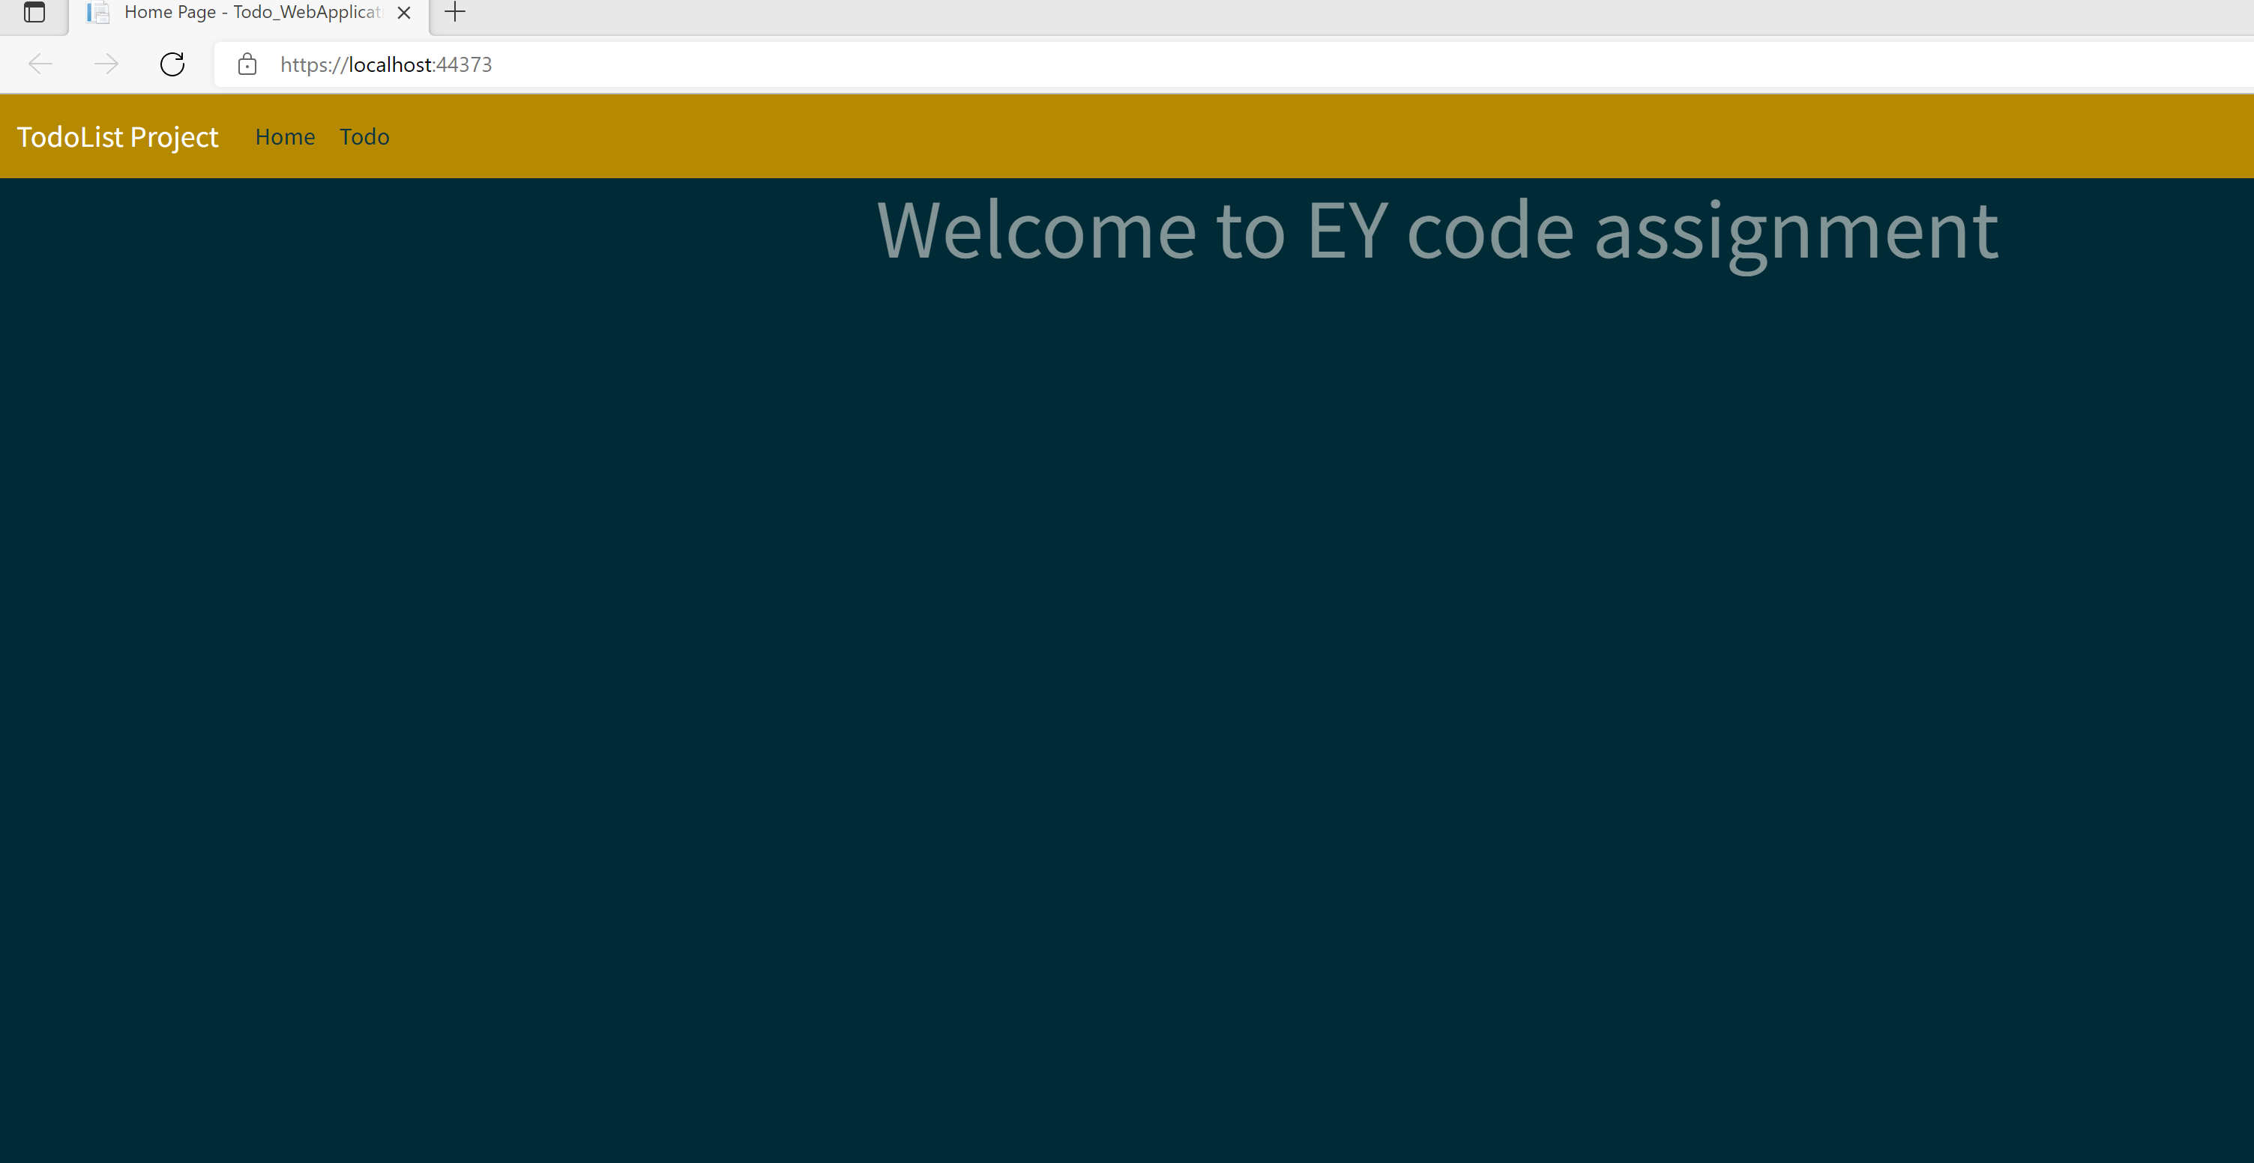

1. The user can perform CRUD operation using below screen:

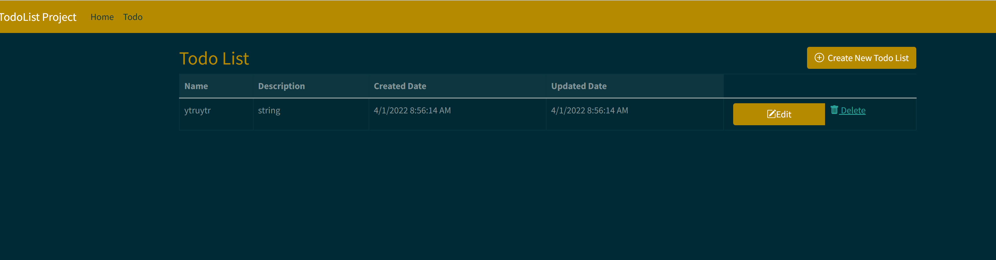

1. Using N-tier architecture, I developed the application so that the application can divided into logical layer and physical tiers. Each layer can perform its own functionality. E.g. as shown in the below screen – The logical layer comprises of DataAcess and Models whereas the Physical layer consists of WebApplication.

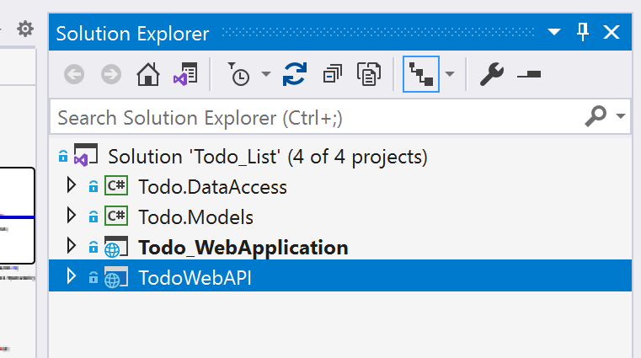

1. The Rest based web API, has been created using repository pattern so that it can hide the details of how exactly the data is stored and be retrieved in the respective repository.

Git Repository:

1. Actual code:

* Copy the link on your browser: [Meghadhote/Todo_list (github.com)](https://github.com/Meghadhote/Todo_list)
* Download the code on your machine using Code dropdown-highlighted as a green button in below screen, select download and specify the local path of your machine.

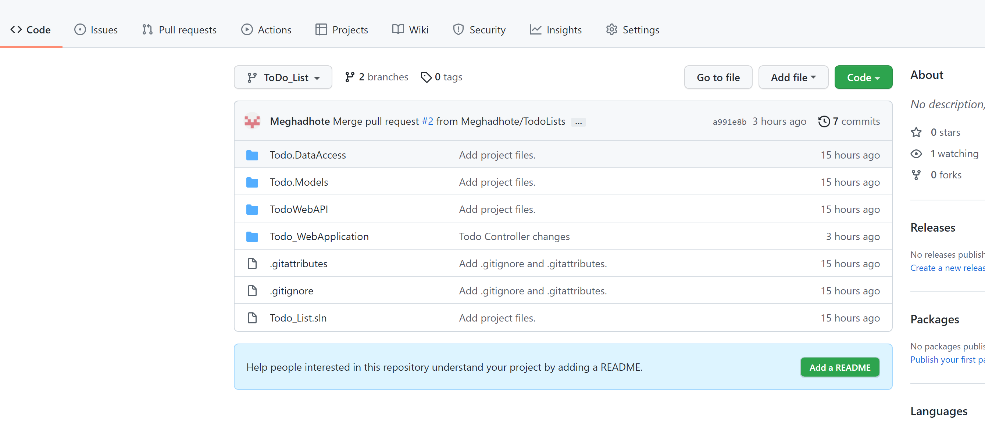

* I have used the below version of Visual Studio

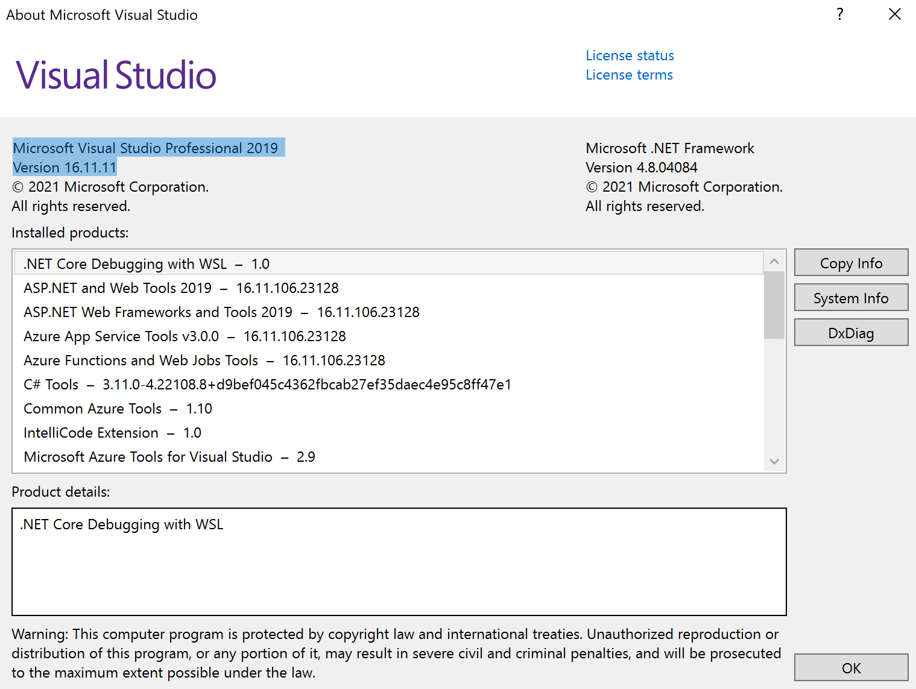

* Open the downloaded solution in Visual Studio.
* In VS-Solution explorer right click and select properties in order to run the API and Application at the same time as shown in the below picture.

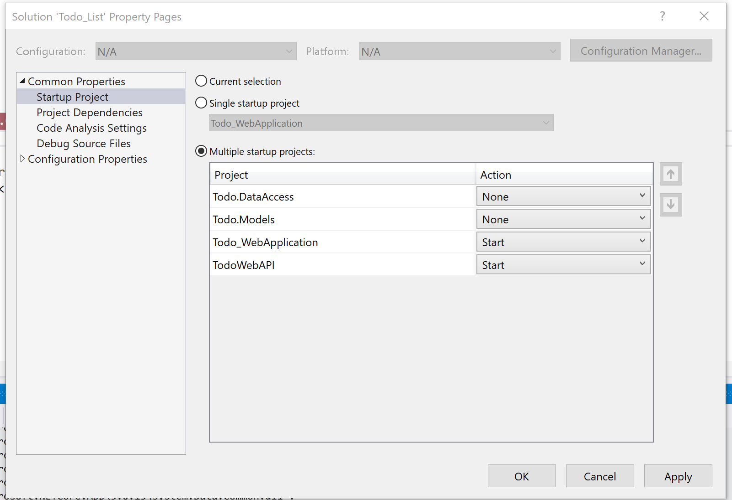

1. Publish Package:

* Copy the link on your browser: [Meghadhote/Todo_Packaging (github.com)](https://github.com/Meghadhote/Todo_Packaging)
* Download the code on your machine using Code dropdown-highlighted as a green button in below screen, select download and copy the project from download folder to any folder of your choice.

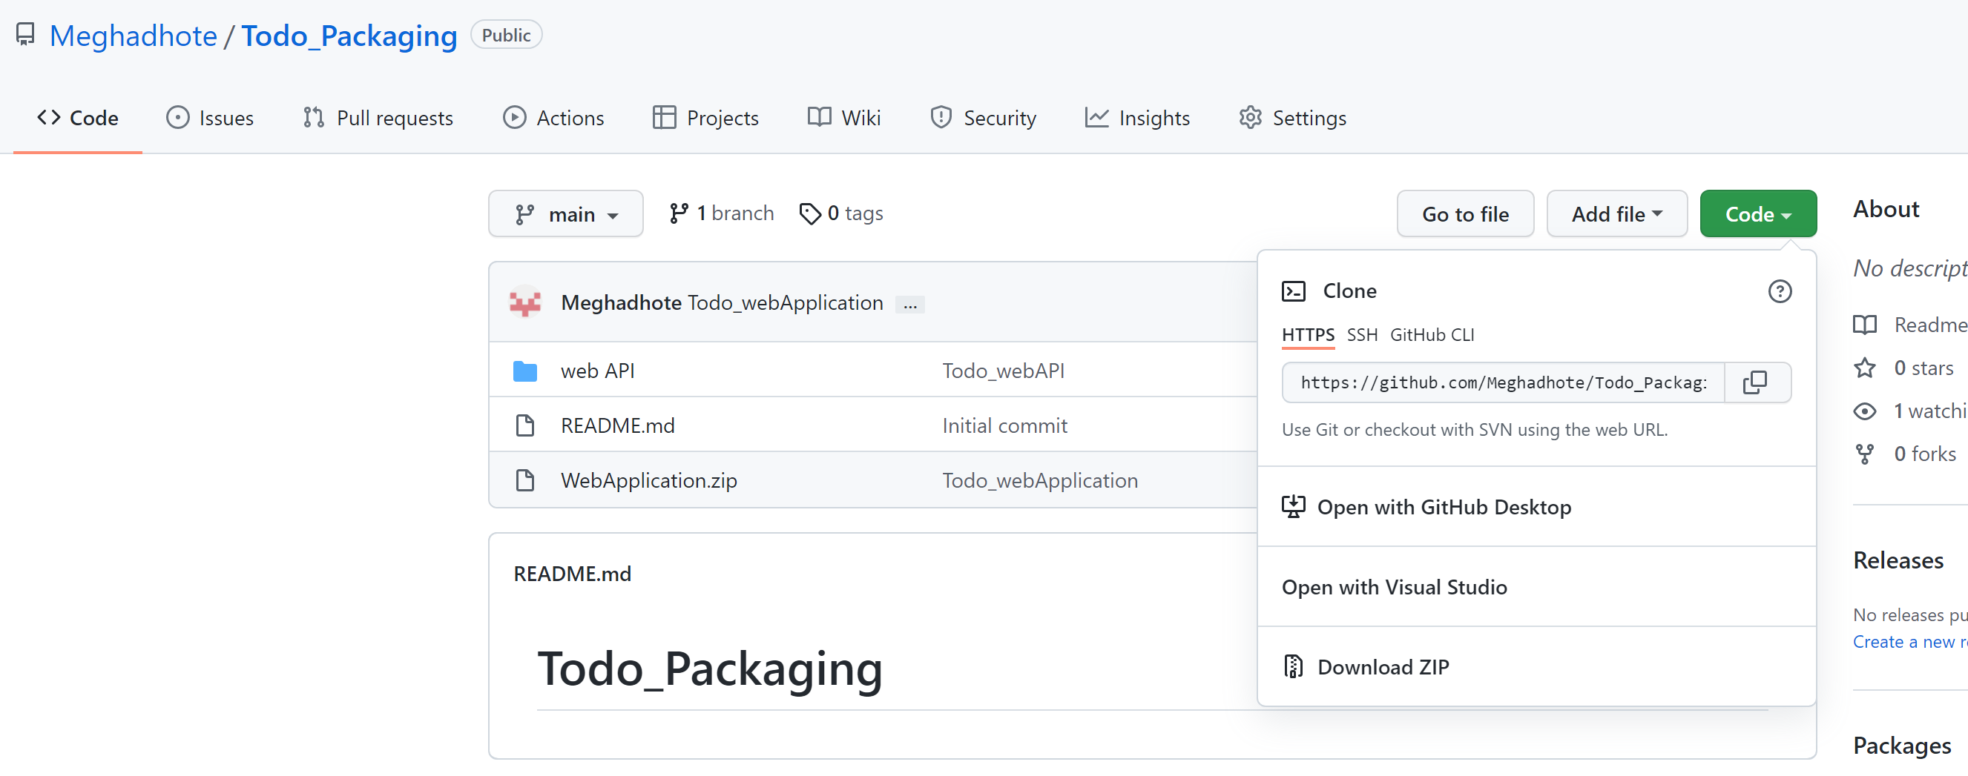

* Once the download is completed, unzip the folder Webapplication.zip
* To run the asp.net core packages, download the .net core hosting bundle from the url: <https://dotnet.microsoft.com/en-us/download/dotnet/5.0>
* Open IIS, Add the website by right clicking on Sites -highlighted in grey as per the below screen.

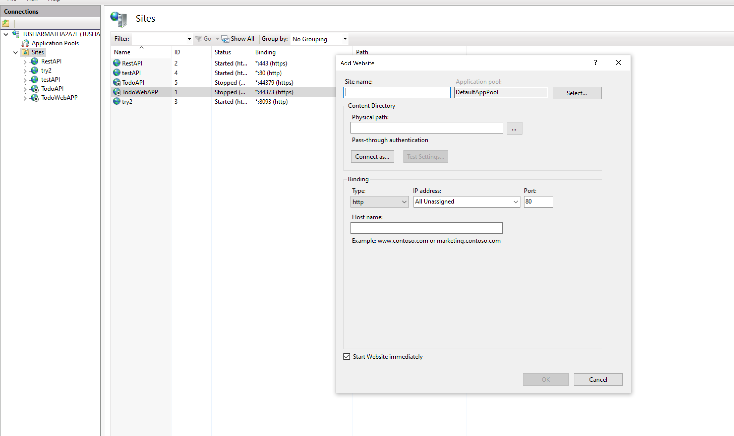

* Enter the following details in your Add website pop up screen as per the below screen, select the physical path where you saved the API([web API](https://github.com/Meghadhote/Todo_Packaging/tree/main/web%20API)) on your machine after downloading from github

<Note>Make sure that the binding should be https using port-44379 and select SSL certificate as shown in below screen</Note>

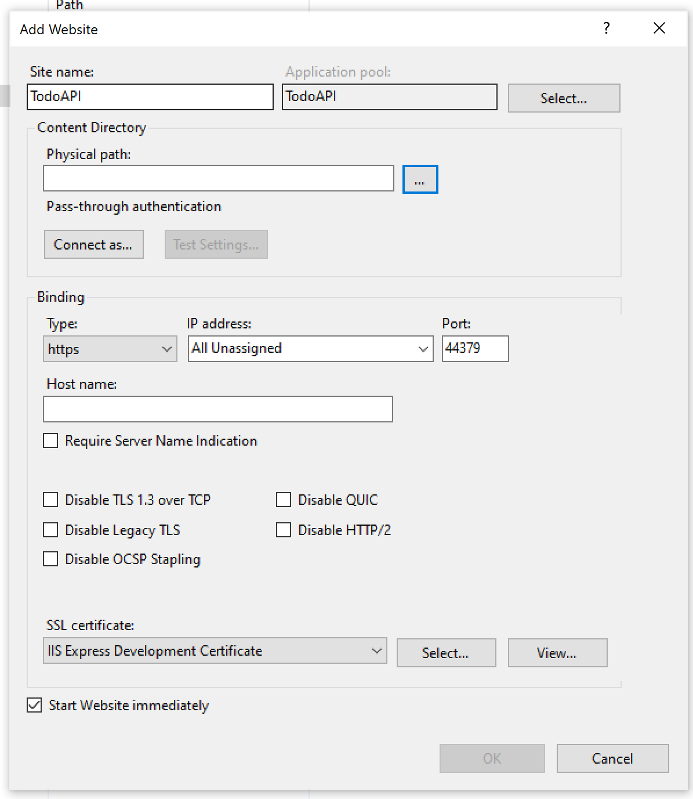

* Add the application by clicking on sites and select add website option, Enter the following details in your Add WebApplication pop up screen as per the below screen, select the physical path where you saved the webapplication on your machine after downloading from github

<Note>Make sure that the binding should be https using port-44373 and select SSL certificate as shown in below screen</Note>

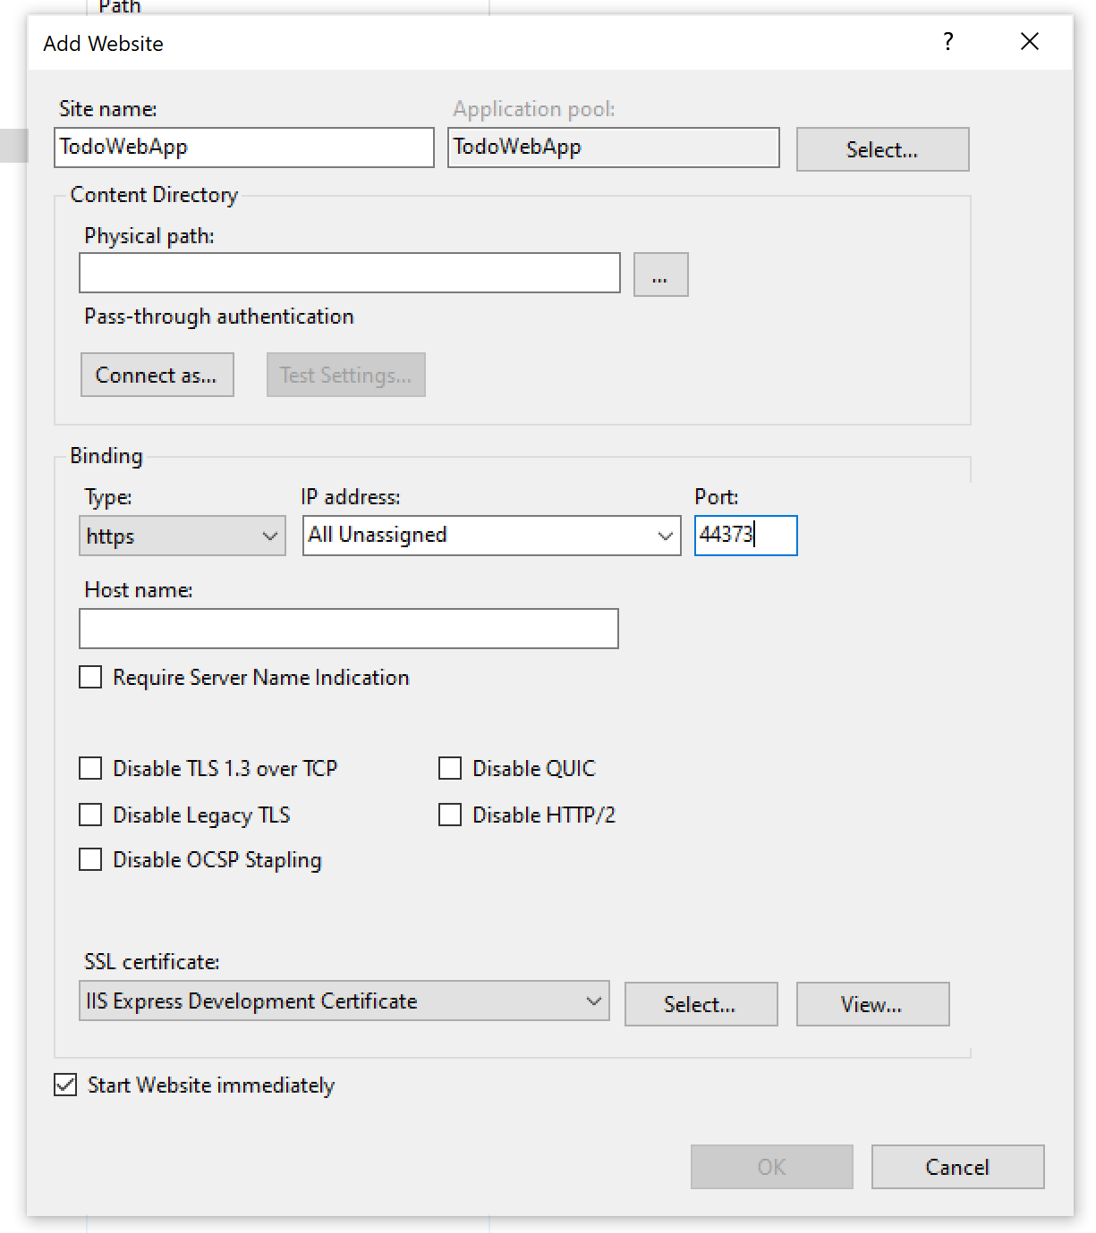

* Browse the Application by selecting the Application and clicking on browse link from right hand panel as shown in below screen.

